Final report

#### Introduction

With the aim of making vegans’ life easier and better, Vegan in HK is a website designed for Hong Kong vegan residents as well as visitors to find nice and suitable food for consuming. In this report, the process of building this data-driven website will be elaborated.

#### Strategy

**Site objectives**

The idea of designing a food recommendation website especially for vegans is motivated by my own experience. As a vegan who newly come to Hong Kong, I found it is extremely hard to meet my special diet when eating outside, since most of the restaurants provides few vegetables and the price is considerably high. Moreover, finding the suitable place where sells fresh vegetables and fruits is difficult as well, for most fruits and vegetables in supermarkets are imported and quite expensive. My interview with several vegetarian friends studying in Hong Kong indicates the similar problem as I encountered.

Thus, there comes the problem I intend to fix through designing a data-driven website: How to help vegans in Hong Kong to sustain their special diet in an economical way, and finally make their vegan lifestyle more convenient and interesting? And the goal of this website contains two parts: 1. Help vegans save time on information searching when they want to consume vegan food in Hong Kong. 2. Make HK vegans’ diet more diverse, interesting and at the same time save money.

**User needs**

The targeting users of this website mainly includes 2 groups: 1. Local vegans who live in Hong Kong. 2. Vegans who newly come and would stay in Hong Kong for a while. In order to find out the needs of my user segment, I interviewed several vegans in Hong Kong and other countries by asking the following two questions (See Figure 1)

|  |
| --- |
| *Q1: How do you find vegan food? What kind of website will be used during searching?* |
| *Q2: What kind of information or services you expect to find in a website serves for vegans?* |

*Figure 1 User needs interview-questions*

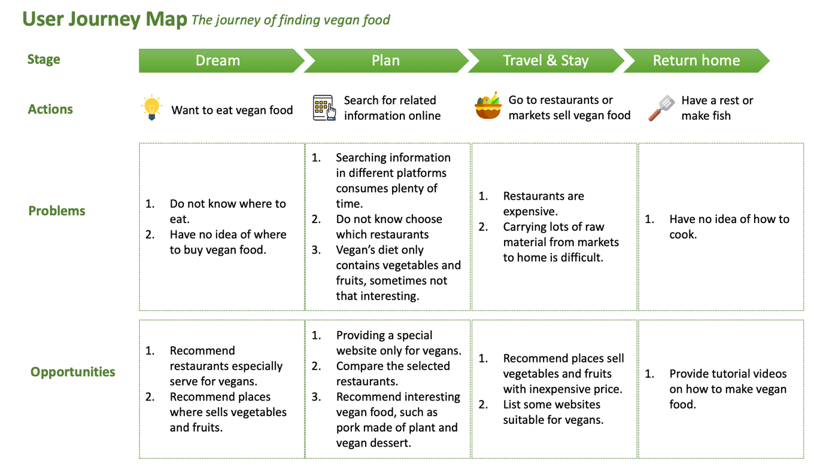Based on the feedback of interview, I develop a user journey map to see how a vegan find the suitable food, examining user needs and explore the opportunities I could seize for website development in a more micro perspective. (See Figure 2)

*Figure 2 User Journey map- the journey of finding vegan food*

According to the journey map, I reclass the information user need into 3 categories: 1. Vegan restaurants 2. Places where could buy vegetables and fruits 3. Tutorial videos on how to make vegan dish.

#### Scope

**Functional specifications**

There are mainly 3 functional specifications of my website when compared with the existing ones in the market.

Firstly, this website is especially for vegan. Actually, there are many different kinds of vegetarians, while vegans are the ones who keep the most rigid eating habit, never consuming any animal product such as milk, butter or cheese. Although there are several existing vegetarian-related websites in Hong Kong, most of them serves for the larger vegetarian group and mainly focus on promoting the benefits of keeping a vegetarian diet. None of these platforms are especially designed for vegan and authentically help them to find the desirable food.

Secondly, it is unwise to compete with *Openrice*, a Hong Kong food recommendation service giant, directly in the aspect of information volume. Thus, my website lists selected vegan restaurants and compare them through data visualization to help users choose restaurant more quickly. Moreover, unique sections are designed to classify different choices, creating interesting scenes to diversify eating experience.

Last but not least, in addition to restaurants recommendation, my website does offer information to help vegans make dish at home through telling users where to buy fruits and vegetables both offline and online. And tutorial videos are listed to empower vegans make delicious food at home.

**Content requirements**

The following contents are finally considered to be listed on my website.

1. 25 vegan restaurants with information includes picture, location, average expense, rate of good comment, short description, cuisine category.
2. 97 Hong Kong street markets with information includes, location, contact information, opening time, number of fruit shop and vegetable short inside.
3. 6 websites which sells vegan food with link, short description, delivery information.
4. 9 tutorial video which teaches vegans how to make dish at home.

#### Structure

After defining the problem and user needs, an information architecture is developed to make all the content logical and well connected. Please see the site map of Vegan in HK as Figure 3. Three categories marked with green stars are the main functional sections, storing the information which vegans needs to find suitable food in Hong Kong. Moreover, contact us section is design for feedback collecting and footer includes copyright, contact information, navigation as well as an overall description of this website.

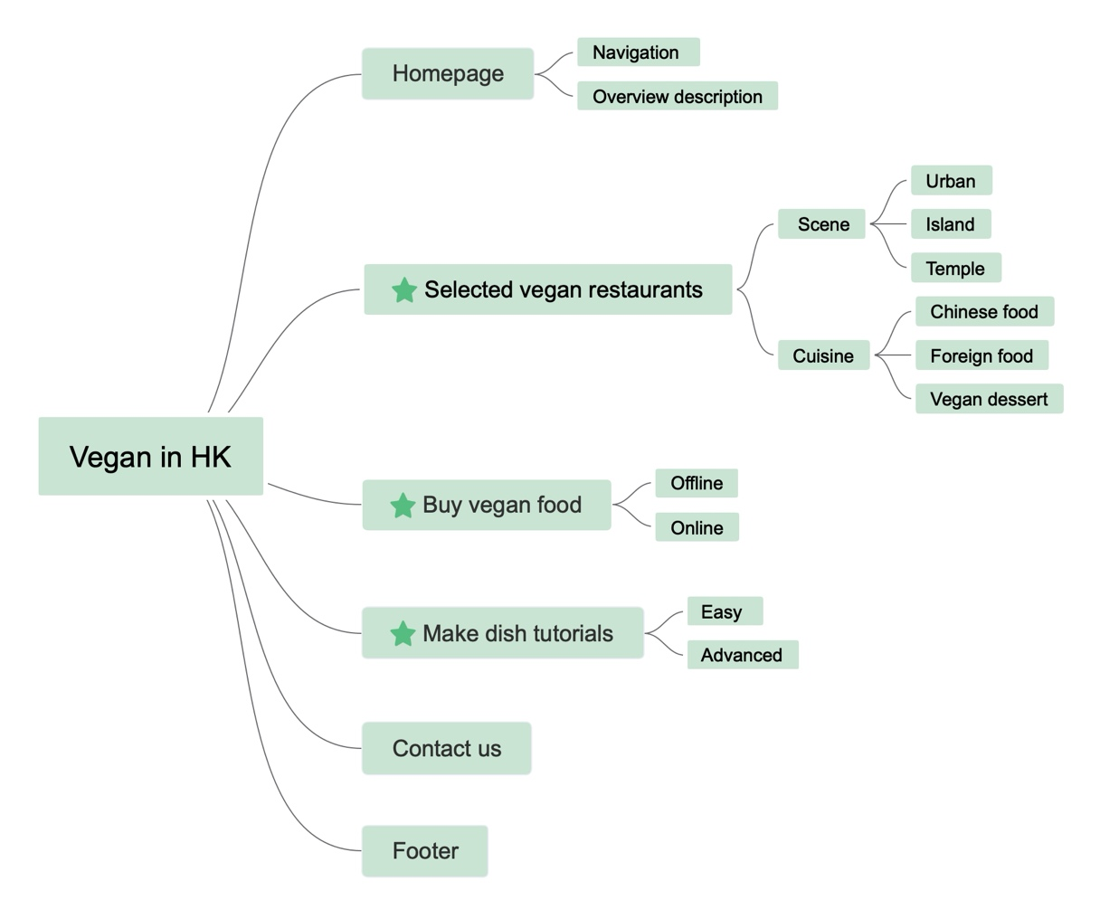

*Figure 3 Site map- Vegan in HK*

#### Skeleton

During the prototyping stage, a low-fidelity wireframe of my website is developed according to the information hierarchy, depicting the interface and navigation design in a more figurative way. (See Figure 4-9) In order to validate if users could go through my web pages smoothly according to my embedded navigation, I interviewed 5 people to gain feedback for further improvement. Three suggestions from my respondents are highly intelligent and valuable: 1. *Arron* said it could be much better if there’s a “start” button on the center of the landing page since this would make users spend less time on scrolling the screen. 2. *Qian* suggested the link embedded in the pop-up window of map function should be connected to google map. By doing so, when user click the link, google map app could be called out automatically and guide users travel to the restaurants. 3. *Lei* thought the color of the filtering button should be changed when it is selected.

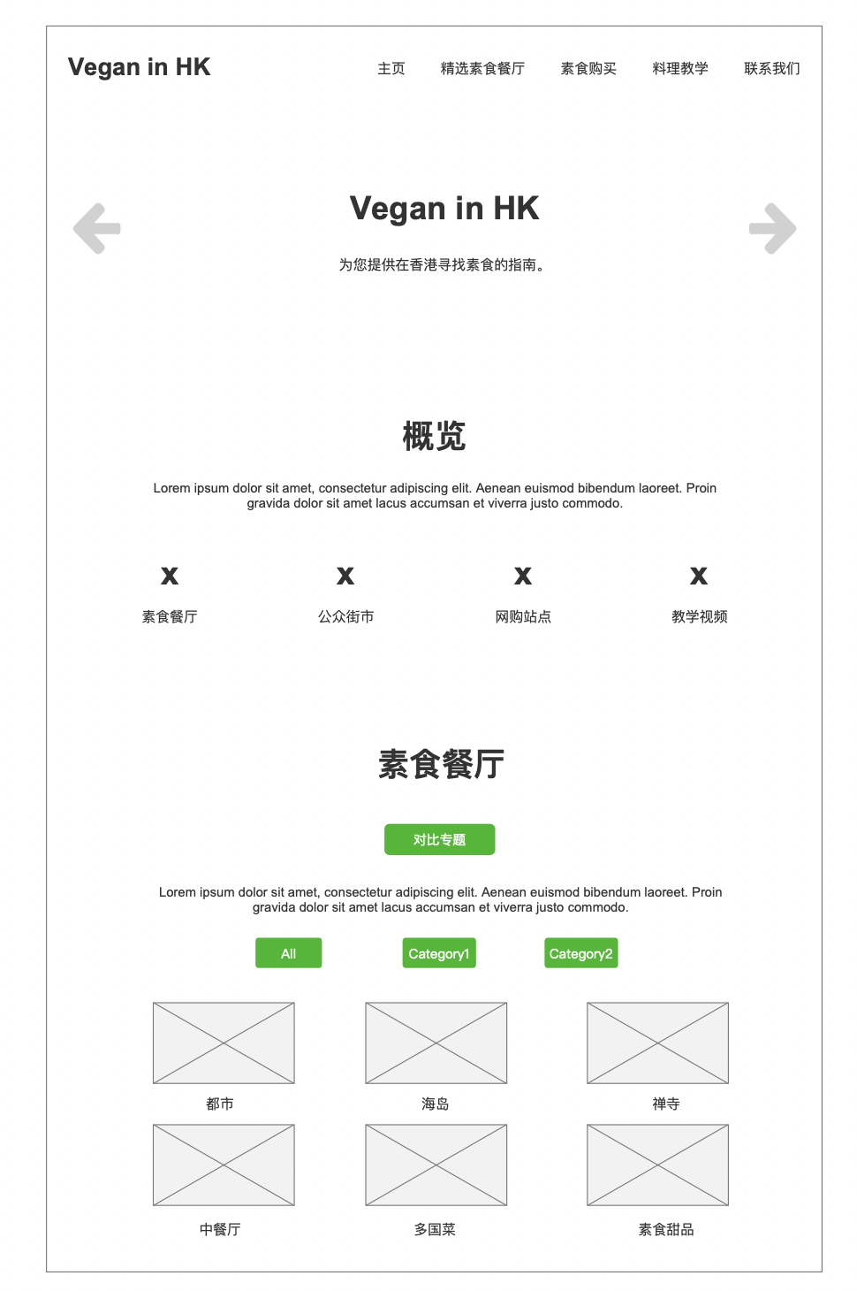

*Figure 4 Wireframe- Homepage part 1*

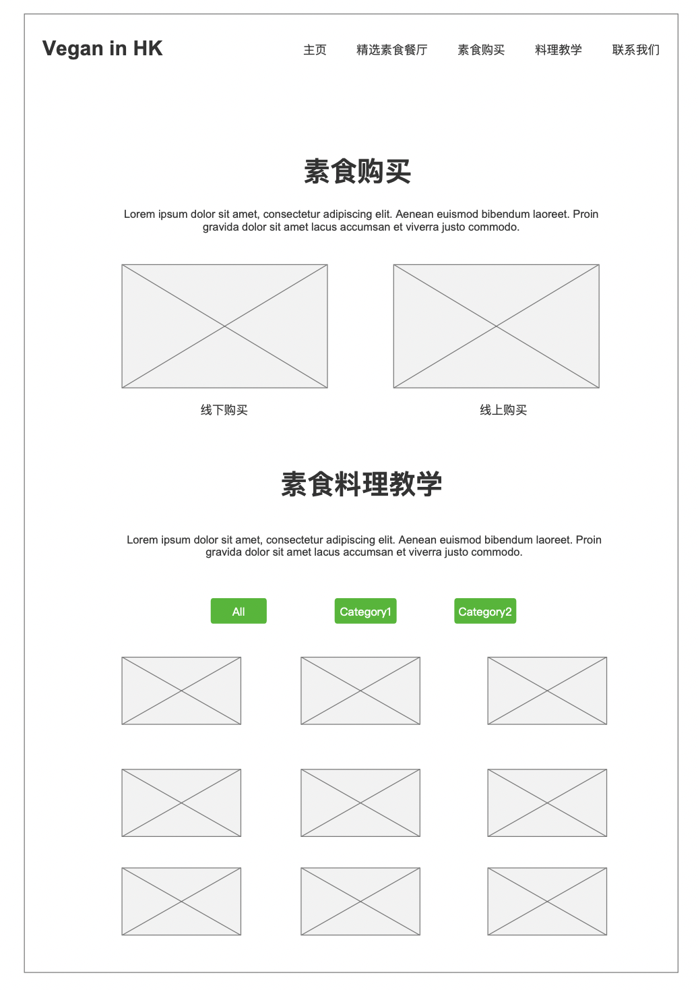

*Figure 5 Wireframe- Homepage part 2*

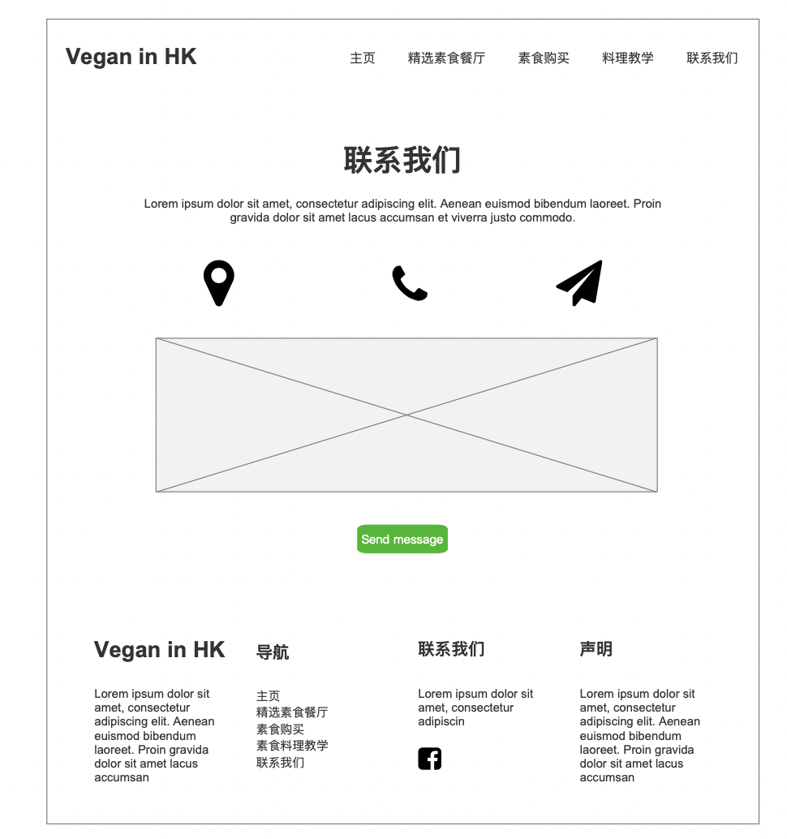

*Figure 6 Wireframe- Homepage part 3*

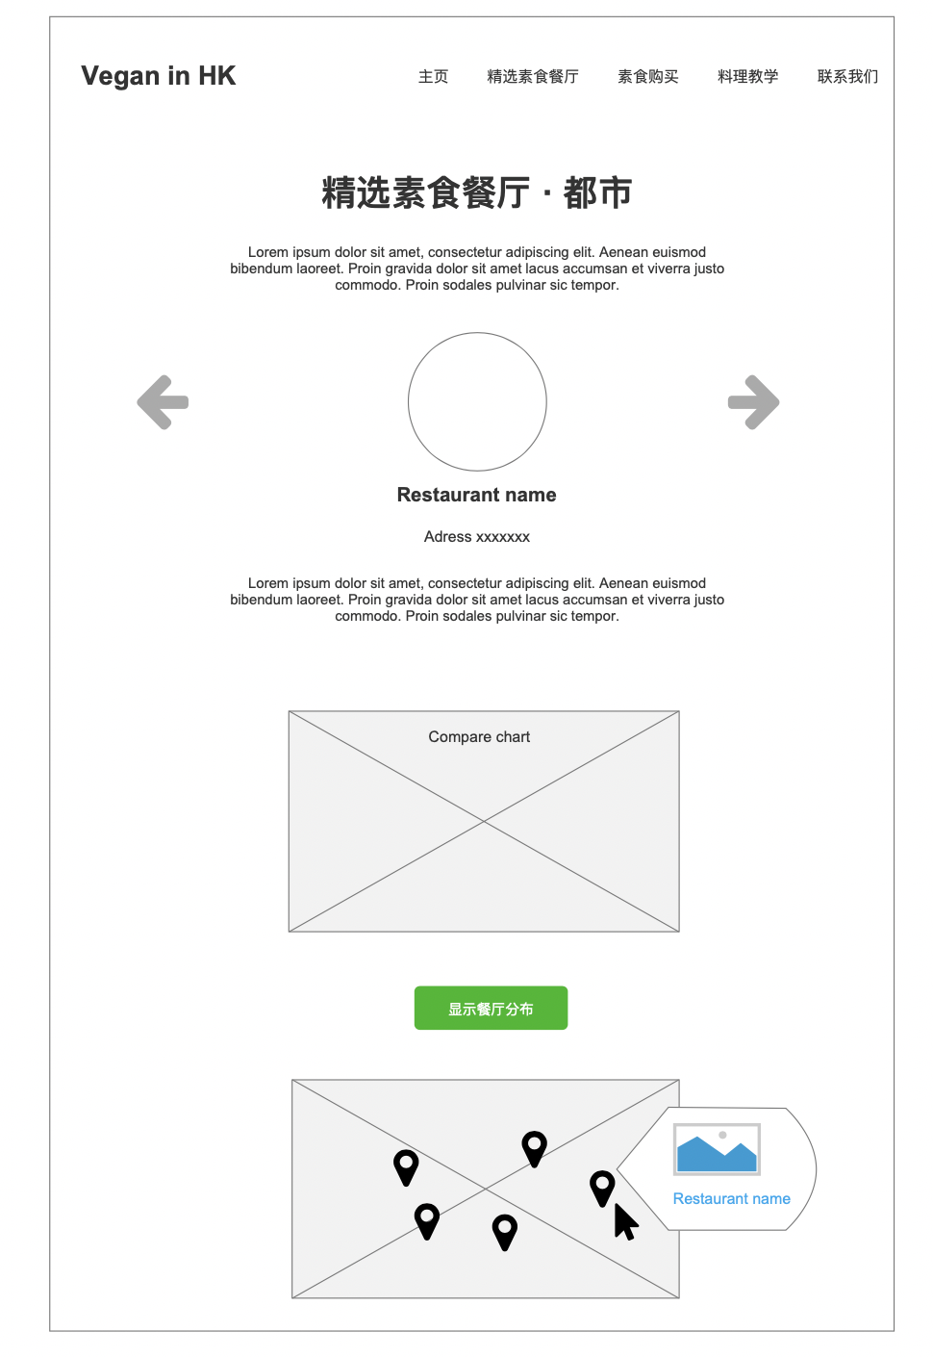*Figure 7 Wireframe- Selected vegan restaurants page*

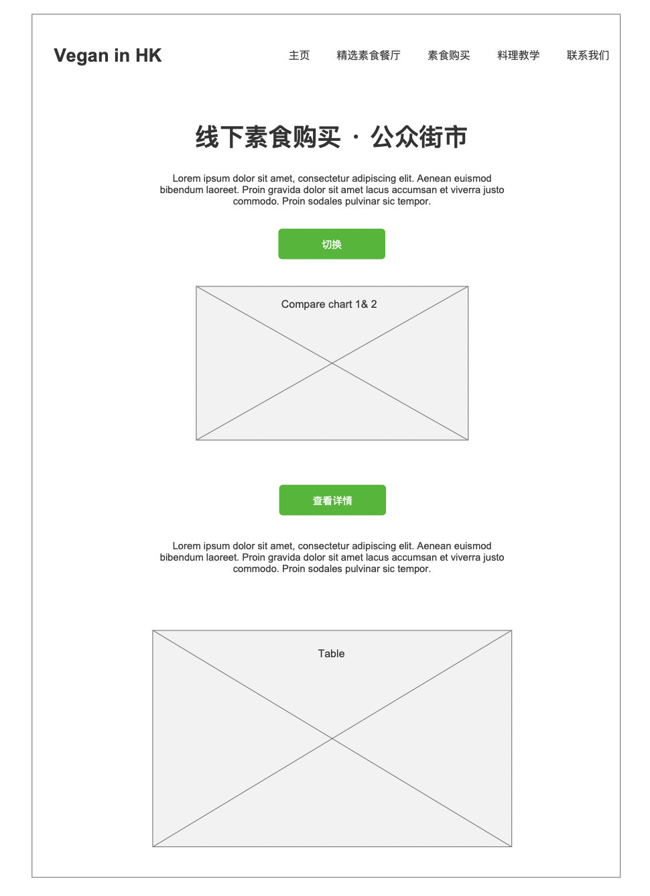*Figure 8 Wireframe- Buy vegan food page offline section*

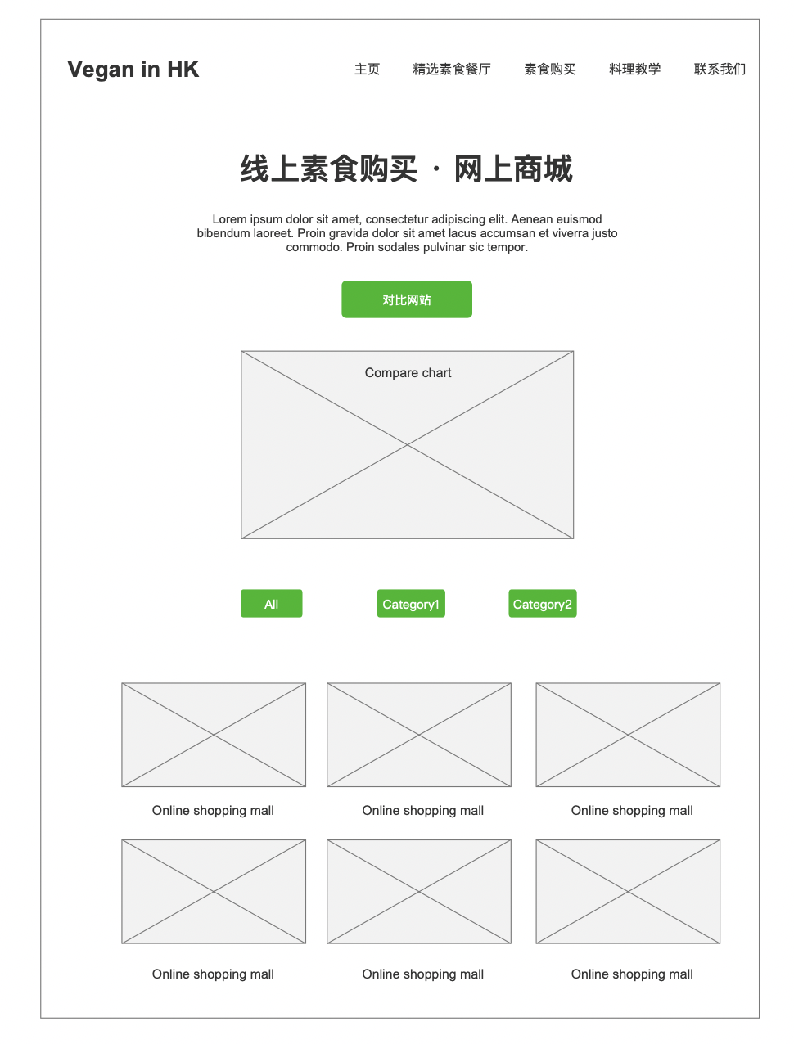

*Figure 9 Wireframe- Buy vegan food page online section*

#### Surface

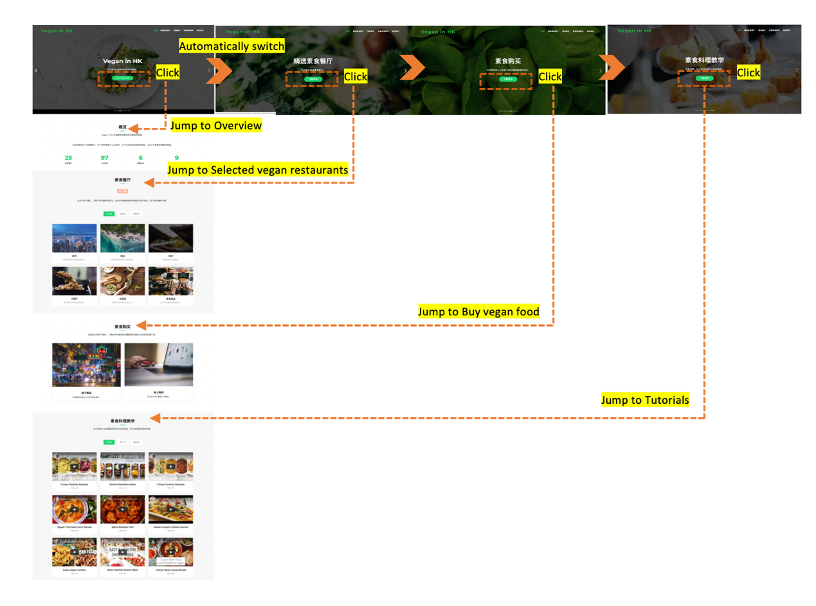Based on the wireframe and insights gained from usability test, I developed a multi-page website to present more information. In general, this website contains two hierarchies: 1. Homepage mainly provides navigation 2. Detailed page focuses more on functional visual design.

*Figure 10 Homepage navigation design logic*

When users landing to my homepage, the first thing they see would be a set of automatically playing pages (See Figure 10). Each page consists a short description and a clickable button which leads users jump to the main section quickly. This idea is partly inspired by the advice gained from usability test. It helps users save energy spent on scrolling pages and get more easily to arrive their interested sections.

In “精选素食餐厅” section, I classified 25 selected vegan restaurants and cafes into 6 themes including: Urban, Island, Temple(grouped according to the environment), Chinese cuisine, Foreign cuisine and vegan dessert (grouped according to the cuisine), to deliver the message that vegan diet could be diverse and fancy as well. Moreover, to meet the goal of making vegan’s life more economical, I provide “price-rate of good comment” chart to visualize the data, thus assisting the users make decision quickly. The charts are employed not only in comparing different themes but also the specific restaurants. (See Figure 11) At the same time, the map shows the location of each restaurants. When user click in the pop-up window in the map, they would jump to google map directly, which saves extra steps for users if they want to search the route from their home to the destination. (See Figure 12)

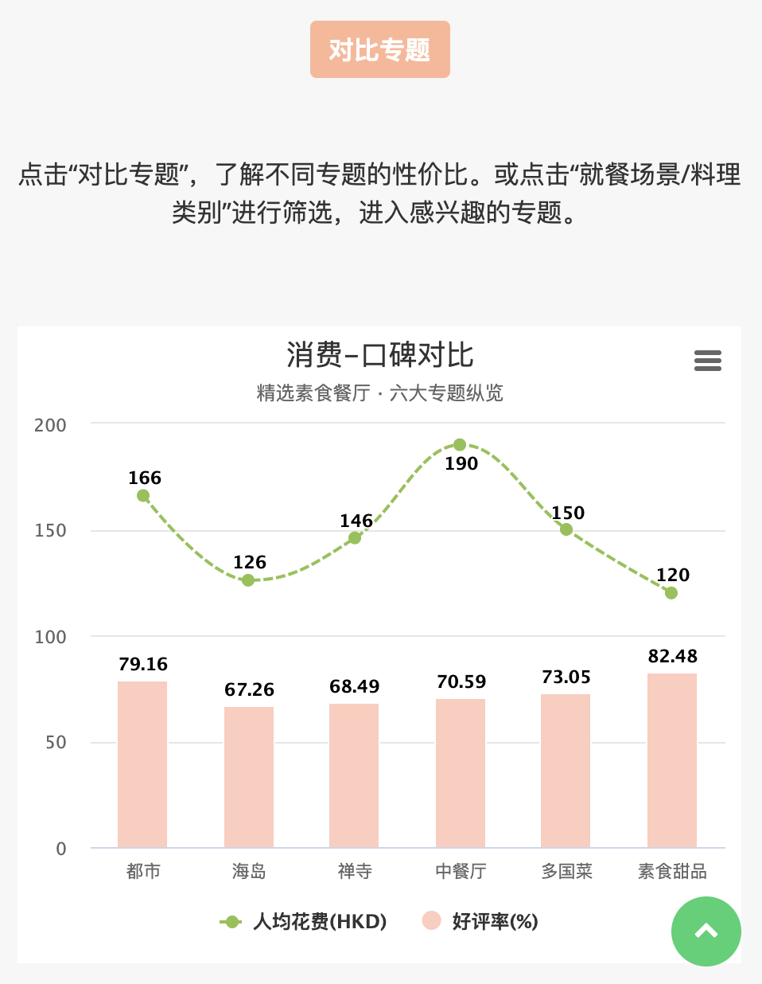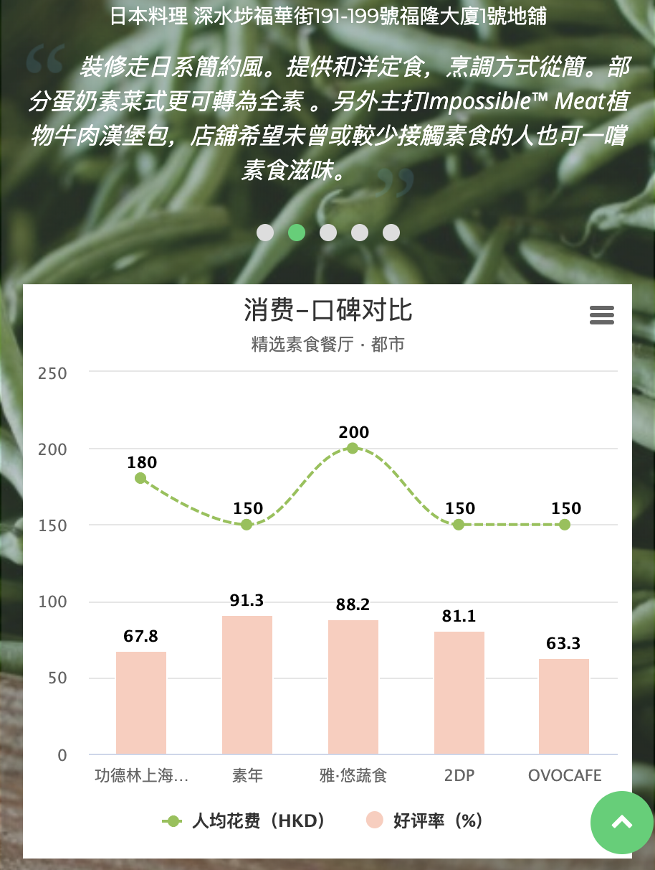

*Figure 11 Detailed page- Data visualization “price-rate of good comment” chart*

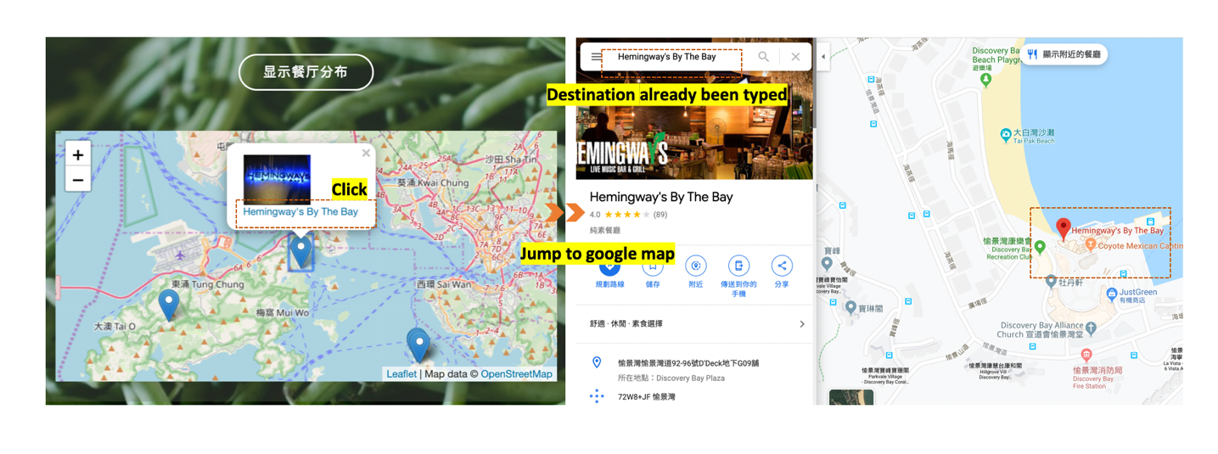

*Figure 12 Detailed page- Map function*

In “素食购买” section, I employed bubble chart to compare 97 street markets under HK Food and environmental hygiene department, using number of fruit shops and vegetable shops in each market as dimensions. Also, I defined the top 10 markets which are suitable for vegans based on the ranking and provide all the detailed information in *Airtable* classified by districts. (See Figure 13)

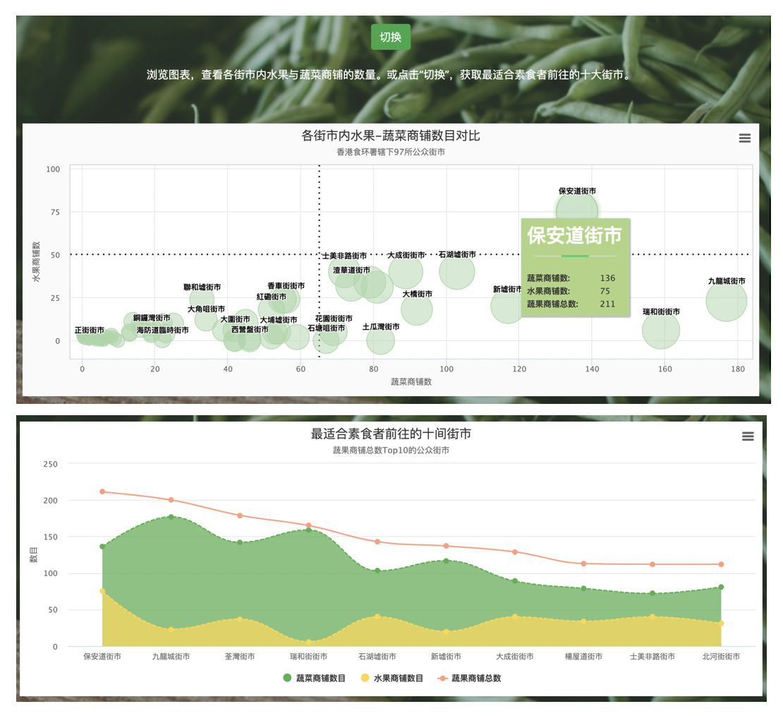

*Figure 13 Detailed page- Data visualization bubble chart and combined chart*

Due to the special geographic situation of Hong Kong, more than 90% of the vegetables and fruits are imported, which contributes to the high price of the products. Plus, for the fresh vegetables are hard to preserve and need more labor to handle with, most restaurants provide limited vegetables to save cost. Thus, it is quite hard for vegans who never eat meat or any animal products in Hong Kong to meet their special diet in an economical, easy and interesting way. Thus, designing a website for this group based in Hong Kong is necessary.

#### Scope

Introduction

Strategy (Site Objectives, user needs)

Scope

Structure & Skeleton

Surface (Five-second Testing, Think aloud Testing, A/B Testing)

Performance Measurement

Conclusion (Limitations, suggestions)